

*Creating virtual and physical experiences that enable people to live more fulfilling lives.*

**Learning To Code For Early Readers**

Data Review & Executive Summary

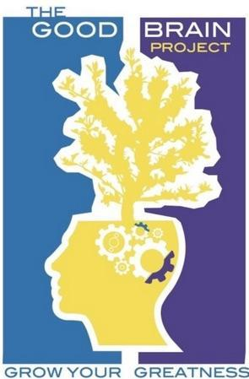 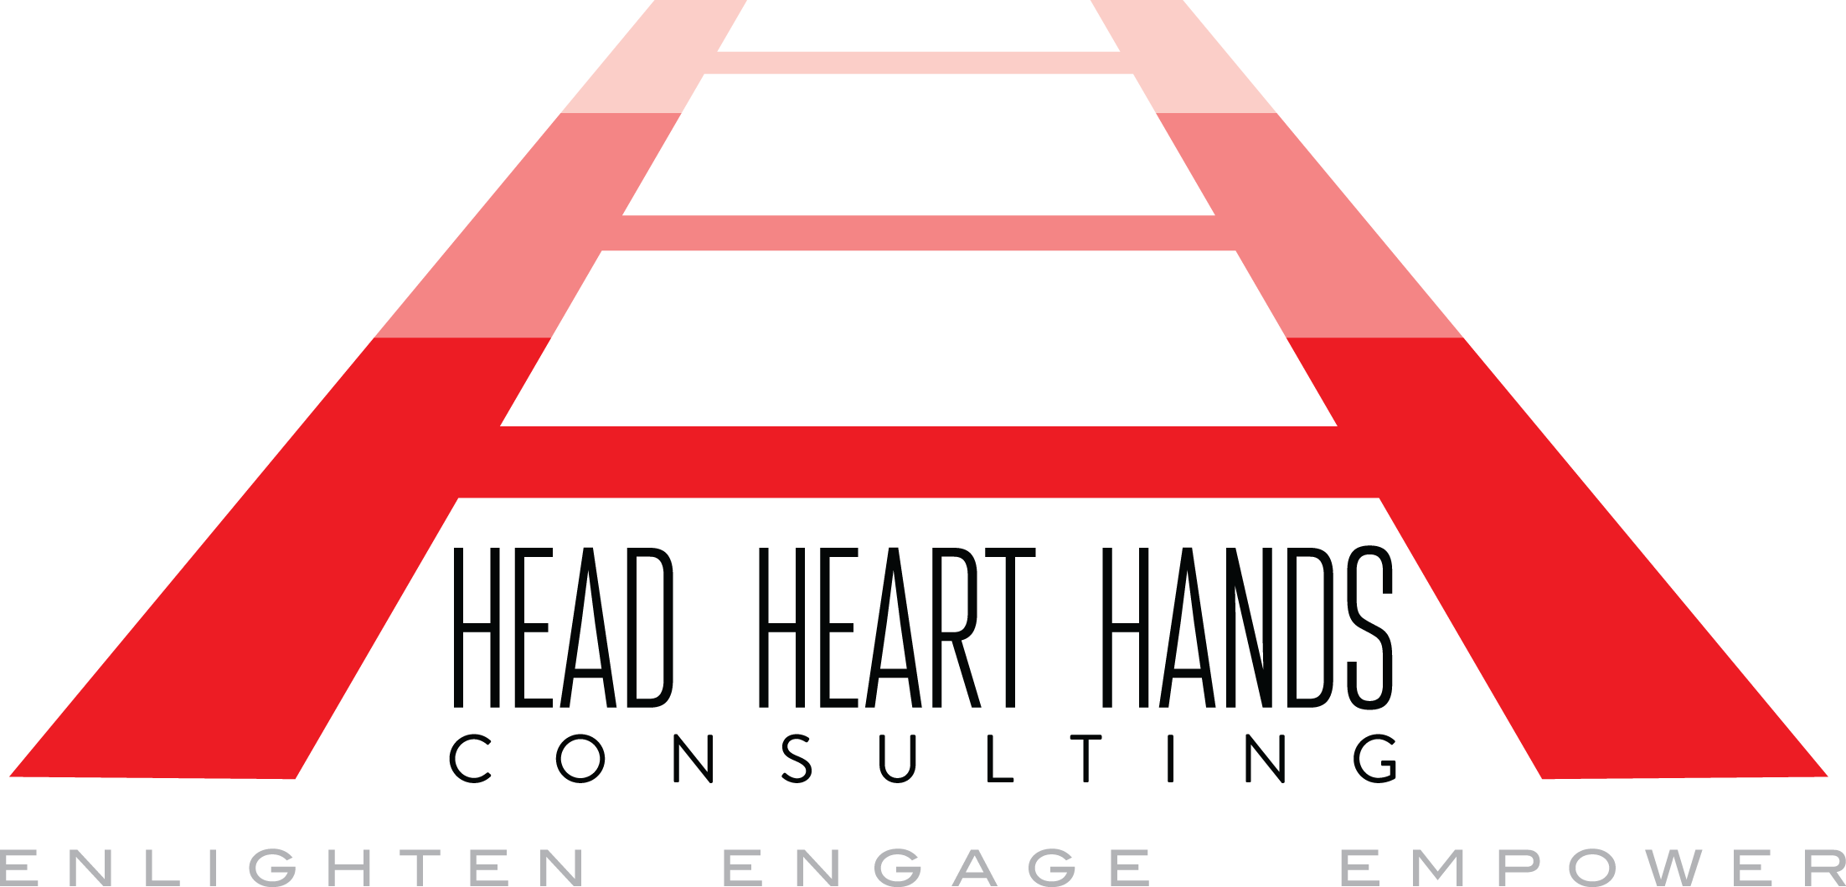

**Proposal**

|  |  |  |
| --- | --- | --- |
| **Focus Group Overview & Facts**  Head Heart Hands Consulting LLC in collaboration with The GoodBrain Project has conducted 3 Focus Groups with Formless’s target consumer base--urban children at 2nd and 3rd grade reading levels. For the purposes of meeting the timeline and additional requirements for the scope of work, and in order to follow cautionary guidelines during COVID, Focus Groups were conducted through an after-school program at the Henry Johnson Charter School in Albany, NY, limiting contact with parents and student guardians. Tom Mueller served as our point of contact at HJCS and offered robust feedback from the perspective of an educator, as well as the School’s Dean, who knows his students very well.   * A total of 14 students were surveyed over a period of 1 week * A total of 3 Focus group sessions in 3 configurations were conducted between 11.12-11.19 * A total of 8 3rd graders and 6 2nd graders were surveyed * A total of 4 2nd grade girls and 2 2nd grade boys were surveyed * A total of 4 3rd grade girls and 4 3rd grade boys were surveyed * All students were between age 7-8 * Focus groups were conducted from 4-5 PM * Students were guided through the material by facilitators, but no answers were provided by facilitators * Facilitators asked & answered clarifying questions, but did not correct student’s incorrect responses * Students were informed that answers could be found in the back of the book * Only one student chose to seek out correct answers, but did not express any desire to copy them * Students responded favorably to the experience overall * Students overwhelmingly and completely loved the augmented reality | | |
|
|
| **Purpose/Objective:**  To provide FORMLESS with feedback from prospective consumers using a sample set of exercises from Little Hackers instructional workbook. Our goal was to present meaningful research data to assist FORMLESS in identifying opportunities and mitigate barriers to successfully meeting product requirements for optimized engagement, learning, and enjoyment. | | |
|
|
| **Engagement & Enjoyment:**   * Engagement was 100% for both 2nd and 3rd graders, as well as girls and boys (no distinction in engagement between age or gender)   + Students expressed interest in “hacking” and “writing code” that contributed to the AR   + Students were more engaged with the AR than the story itself * Enjoyment was also 100% for both 2nd and 3rd graders, as well as girls and boys (no distinction in enjoyment between age or gender)   + 100% of Students said they “loved the AR!”   + 85% of Students expressed frustration with having to “write too many letters” and “read so many letters. | | |
|
|
| **Accessibility & Effectiveness:**   * 88% of total students struggled to **read** and **understand** the text. * 12% of total students were able to **read/sound-out** the text. * 100% of 2nd graders struggled to **read** and **understand** the text. * 2% of 2nd graders were able to **read/sound-out the text.** * 90% of 3rd graders struggled to **read** and **understand** the text. * 10% of 3rd graders were able to **read/sound-out** the text. * Despite the seemingly simple nature of the tasks (and the ability/option to look for the answer in the back of the booklets), 95% of students were unable to produce more than 3 correct responses * Of 14 students, only 2 understood the connection between “copying” code and “altering” or “hacking” code. * 85% of total students understood that code is “computer language.” * Students who thought they knew what hacking is, believed it to be “getting into someone else’s information”, “stealing someone’s password.” * Within the first 7 minutes of each session, all 14 students understood (at least for the hour) that “hacking” code is not a “criminal activity.” * 25% of all students understood that to ‘hack’ code, means to change or alter it, but only 2 students succeeded in making the connection between the code they were copying and how they were ‘hacking.’ * 100% of students noted that the characters were cool * 85% of students noted that the characters “looked like them.” | | |
|
|
| **Influences & Recommendations for Improvement:**   * Focus groups were conducted at the end of a full school day, where a rigorous academic environment requires much of their focus and attention. * Many focus group participants have experienced mild to significant trauma that affects how they respond to new people and how they respond in a learning environment. * Recommendation #1: Increase the age of target customer to 4th and 5th grade of children ages 9-11 (k-3 students are LEARNING TO READ; 4+ students are READING TO LEARN, rendering students unable to place themselves (tree house? garage?) and make the intellectual leaps required by the tasks. * Recommendation #2: In order to reach current target customer: animate majority of content and story using closed captioning (to help promote and reinforce reading fluency and comprehension) and use the physical booklet for writing out actual code. * Recommendation #3: Create a booklet tool that does not require students to flip the page in order to answer a question which asks for them to reference content on the previous page * Recommendation #4: If possible, make all of the QR codes (besides the initial one) “do” what the ‘hacked’ code says it does. One of the challenges to making the connection between their own work and what they saw pop out of AR, is that some tasks demonstrated it and others did not. | | |
|
|
| **Narrative Summary:** | | |
| **What we thought would happen:**  Our hypothesis was that while most kids would be highly engaged and enjoy the content, the length and complexity of the reading required of them in order to understand and approach the assigned tasks would be too challenging for readers ages 7 and 8. As is mentioned in the recommendation section, and as most research suggests, children ages 3-8 are learning to read, while students 9+ are reading to learn. | **What Happened:**  Our hypothesis was accurate. 99% of Students required some level of “direct instruction” for every page of the book. All but one student struggled to understand, gain proficiency, and/or master the actual concepts and applications. | **What We Suggest Going Forward:**  First, keep going! Formless should consider at least two options (and many more)   * Increase the intended age/grade level of participants, which would require modifying/shortening the “storyline” to be a little more “mature” for an older audience * Maintain the originally selected grade level of participants and revise the tool for full animation (with subtitles) using the booklet for code writing practice. |
| **Who were the kids?**   * All students attend the Henry Johnson Charter School * The focus groups covered an array of student “archetypes” from “problem students” to “star pupils” * All students’ families qualify for free or reduced lunch, and all students were from marginalized races/ethnicities (Black and/or Latinx) * 95% of students view themselves as strong students, good readers * 75% of students think they are “good” at technology | | |
|
|
| **Facilitation Format:**  Facilitators interviewed students in 3 different configurations.  Day 1: 5 Third Graders, Whole Group (4 girls, 1 boy)  Day 2: One-on-One 2 second graders (both girls)  Day 3: Two Small Groups: one of 3 & one of 4 (2 girls & 2 boys mixed by reading level )/(3 3rd grade boys). | **Facilitation Style:**  Facilitators emphasized the aspects of research and feedback involved in the Little Hackers adventure and agreed that responding to the collective and individual energy in the room would ultimately render the most useful results. Facilitators provided guidance and direct instruction without providing any answers to students. Facilitators established immediate rapport with each student and group based on the high expectations for the students in the school and the small size of the groups. | **Facilitator Impressions:**  If Formless is willing to refine its tools or reconsider raising the age/reading level of the target customer, there’s nothing that kids can’t learn about coding. Digital gaming and technology is to them as legos, blocks, and dolls/figures were to us. The opportunity to “teach” their ideas and imaginings to machines that do what they say, was a joy-filled experience for all. |